CONGESTION
Congestion in a network may occur if the load on the network (the number of packets sent to the network) is greater than the capacity of the network (the number of packets a network can handle.)
CONGESTION CONTROL
Congestion control refers to techniques and mechanisms that can either prevent congestion, before it happens, or remove congestion, after it has happened. We can divide congestion control mechanisms into two broad categories: open-loop congestion control (prevention) and closed-loop congestion control (removal).
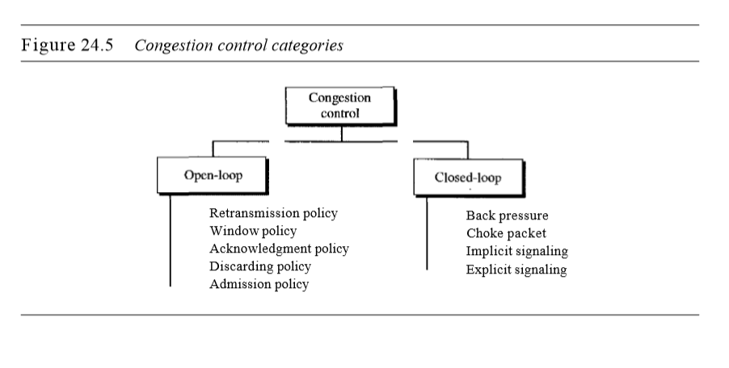

Open-Loop Congestion Control
In open-loop congestion control, policies are applied to prevent congestion before it happens. In these mechanisms, congestion control is handled by either the source or the destination.
Retransmission Policy: Retransmission is sometimes unavoidable. If the sender feels that a sent packet is lost or corrupted, the packet needs to be retransmitted. Retransmission in general may increase congestion in the network. However, a good retransmission policy can prevent congestion. The retransmission policy and the retransmission timers must be designed to optimize efficiency and at the same time prevent congestion.

Window Policy: The type of window at the sender may also affect congestion. The Selective Repeat window is better than the Go-Back-N window for congestion control. In the Go-Back-N window, when the timer for a packet times out, several packets may be resent, although some may have arrived safe and sound at the receiver. This duplication may make the congestion worse. The Selective Repeat window, on the other hand, tries to send the specific packets that have been lost or corrupted.

Acknowledgment Policy: The acknowledgment policy imposed by the receiver may also affect congestion. If the receiver does not acknowledge every packet it receives, it may slow down the sender and help prevent congestion. A receiver may decide to acknowledge only N packets at a time. Sending fewer acknowledgments means imposing fewer loads on the network.

Discarding Policy: A good discarding policy by the routers may prevent congestion and at the same time may not harm the integrity of the transmission. For example, in audio transmission, if the policy is to discard less sensitive packets when congestion is likely to happen, the quality of sound is still preserved and congestion is prevented or alleviated.

Admission Policy: An admission policy, which is a quality-of-service mechanism, can also prevent congestion in virtual-circuit networks. Switches in a flow first check the resource requirement of a flow before admitting it to the network. A router can deny establishing a virtual circuit connection if there is congestion in the network or if there is a possibility of future congestion.

Closed-Loop Congestion Control
Closed-loop congestion control mechanisms try to alleviate congestion after it happens. Several mechanisms have been used by different protocols.

Backpressure: The technique of backpressure refers to a congestion control mechanism in which a congested node stops receiving data from the immediate upstream node or nodes. This may cause the upstream node or nodes to become congested, and they, in turn, reject data from their upstream nodes or nodes. And so on. Backpressure is a node-to-node congestion control that starts with a node and propagates, in the opposite direction of data flow, to the source. The backpressure technique can be applied only to virtual circuit networks, in which each node knows the upstream node from which a flow of data is corning.
Node III in the figure has more input data than it can handle. It drops some packets in its input buffer and informs node II to slow down. Node II, in turn, may be congested because it is slowing down the output flow of data. If node II is congested, it informs node I to slow down, which in turn may create congestion. If so, node I inform the source of data to slow down. This, in time, alleviates the congestion. Note that the pressure on node III is moved backward to the source to remove the congestion.

Choke Packet: A choke packet is a packet sent by a node to the source to inform it of congestion. Note the difference between the backpressure and choke packet methods. In backpressure, the warning is from one node to its upstream node, although the warning may eventually reach the source station. In the choke packet method, the warning is from the router, which has encountered congestion, to the source station directly. The intermediate nodes through which the packet has traveled are not warned. When a router in the Internet is overwhelmed with IP datagrams, it may discard some of them; but it informs the source host, using a source quench ICMP message. The warning message goes directly to the source station; the intermediate routers, and does not take any action.

Implicit Signaling: In implicit signaling, there is no communication between the congested node or nodes and the source. The source guesses that there is congestion somewhere in the network from other symptoms. For example, when a source sends several packets and there is no acknowledgment for a while, one assumption is that the network is congested. The delay in receiving an acknowledgment is interpreted as congestion in the network; the source should slow down.

Explicit Signaling: The node that experiences congestion can explicitly send a signal to the source or destination. The explicit signaling method, however, is different from the choke packet method. In the choke packet method, a separate packet is used for this purpose; in the explicit signaling method, the signal is included in the packets that carry data. Explicit signaling can occur in either the forward or the backward direction.
- Backward Signaling A bit can be set in a packet moving in the direction opposite to the congestion. This bit can warn the source that there is congestion and that it needs to slow down to avoid the discarding of packets.
- Forward Signaling A bit can be set in a packet moving in the direction of the congestion. This bit can warn the destination that there is congestion. The receiver in this case can use policies, such as slowing down the acknowledgments, to alleviate the congestion.

QUALITY OF SERVICE
Quality of service (QoS) is an internetworking issue that has been discussed more than defined. We can informally define quality of service as something a flow seeks to attain.
Flow Characteristics: Four types of characteristics are attributed to a flow: reliability, delay, jitter, and bandwidth.
- Reliability: Reliability is a characteristic that a flow needs. Lack of reliability means losing a packet or acknowledgment, which entails retransmission. However, the sensitivity of application programs to reliability is not the same. For example, it is more important that electronic mail, file transfer, and Internet access have reliable transmissions than telephony or audio conferencing.
- Delay: Source-to-destination delay is another flow characteristic. Again applications can tolerate delay in different degrees. In this case, telephony, audio conferencing, video conferencing, and remote log-in need minimum delay, while delay in file transfer or e-mail is less important.
- Jitter: Jitter is the variation in delay for packets belonging to the same flow. For example, if four packets depart at times 0, 1, 2, 3 and arrive at 20, 21, 22, 23, all have the same delay, 20 units of time. On the other hand, if the above four packets arrive at 21, 23, 21, and 28, they will have different delays: 21,22, 19, and 24. For applications such as audio and video, the first case is completely acceptable; the second case is not. For these applications, it does not matter if the packets arrive with a short or long delay as long as the delay is the same for all packets. For this application, the second case is not acceptable.Jitter is defined as the variation in the packet delay. High jitter means the difference between delays is large; low jitter means the variation is small.
- Bandwidth: Different applications need different bandwidths. In video conferencing we need to send millions of bits per second to refresh a color screen while the total number of bits in an e-mail may not reach even a million.

TECHNIQUES TO IMPROVE QoS
Some techniques that can be used to improve the quality of service. We briefly discuss four common methods: scheduling, traffic shaping, admission control, and resource reservation.
1.Scheduling
Packets from different flows arrive at a switch or router for processing. A good scheduling technique treats the different flows in a fair and appropriate manner. Several scheduling techniques are designed to improve the quality of service. We discuss three of them here: FIFO queuing, priority queuing, and weighted fair queuing.
FIFO Queuing
In first-in, first-out (FIFO) queuing, packets wait in a buffer (queue) until the node (router or switch) is ready to process them. If the average arrival rate is higher than the average processing rate, the queue will fill up and new packets will be discarded. A FIFO queue is familiar to those who have had to wait for a bus at a bus stop.
Priority Queuing
In priority queuing, packets are first assigned to a priority class. Each priority class has its own queue. The packets in the highest-priority queue are processed first. Packets in the lowest-priority queue are processed last.
A priority queue can provide better QoS than the FIFO queue because higher priority traffic, such as multimedia, can reach the destination with less delay. However, there is a potential drawback. If there is a continuous flow in a high-priority queue, the packets in the lower-priority queues will never have a chance to be processed. This is a condition called starvation.
Weighted Fair Queuing
A better scheduling method is weighted fair queuing. In this technique, the packets are still assigned to different classes and admitted to different queues. The queues, however, are weighted based on the priority of the queues; higher priority means a higher weight. The system processes packets in each queue in a round-robin fashion with the number of packets selected from each queue based on the corresponding weight. For example, if the weights are 3, 2, and 1, three packets are processed from the first queue, two from the second queue, and one from the third queue. If the system does not impose priority on the classes, all weights can be equal In this way, we have fair queuing with priority.
2. Traffic Shaping
Traffic shaping is a mechanism to control the amount and the rate of the traffic sent to the network. Two techniques can shape traffic: leaky bucket and token bucket.
Leaky Bucket
If a bucket has a small hole at the bottom, the water leaks from the bucket at a constant rate as long as there is water in the bucket. The rate at which the water leaks does not depend on the rate at which the water is input to the bucket unless the bucket is empty. The input rate can vary, but the output rate remains constant. Similarly, in networking, a technique called leaky bucket can smooth out bursty traffic. Bursty chunks are stored in the bucket and sent out at an average rate.
Without the leaky bucket, the beginning burst may have hurt the network by consuming more bandwidth than is set aside for this host. We can also see that the leaky bucket may prevent congestion.
A leaky bucket algorithm shapes bursty traffic into fixed-rate traffic by averaging the data rate. It may drop the packets if the bucket is full.
Token Bucket
The leaky bucket is very restrictive. It does not credit an idle host. For example, if a host is not sending for a while, its bucket becomes empty. Now if the host has bursty data, the leaky bucket allows only an average rate. The time when the host was idle is not taken into account. On the other hand, the token bucket algorithm allows idle hosts to accumulate credit for the future in the form of tokens.
Combining Token Bucket and Leaky Bucket
The two techniques can be combined to credit an idle host and at the same time regulate the traffic. The leaky bucket is applied after the token bucket; the rate of nthe leaky bucket needs to be higher than the rate of tokens dropped in the bucket.
3.Resource Reservation
A flow of data needs resources such as a buffer, bandwidth, CPU time, and so on. The quality of service is improved if these resources are reserved beforehand. 4.Admission Control
Admission control refers to the mechanism used by a router, or a switch, to accept or reject a flow based on predefined parameters called flow specifications. Before a router accepts a flow for processing, it checks the flow specifications to see if its capacity (in terms of bandwidth, buffer size, CPU speed, etc.) and its previous commitments to other flows can handle the new flow.

